Fixture Assembly for Drone Charging Station
Asylon Robotics — Manufacturing & Engineering Internship (Summer 2025)
Project Overview
This project focused on designing a fixture assembly in CATIA V6 (3DEXPERIENCE) to support and interface with Asylon’s autonomous drone charging station. The fixture needed to safely support a 600 lb payload while maintaining structural integrity up to 1000 lb. Key requirements included 360° rotational capability, adjustable lift mechanisms up to 4 ft, and a stable, cost-effective frame suitable for manufacturing.
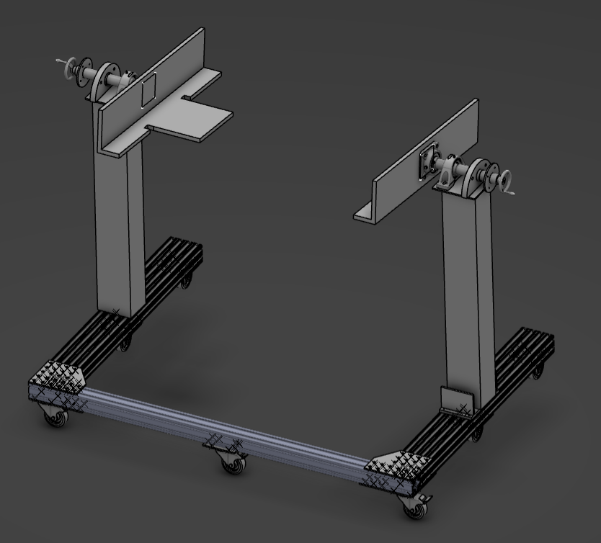
Project Motivation & Objectives
The original goal of this project was to evaluate whether it was more cost-effective to purchase a commercial fixture (~$15,000) or design and build a custom solution in-house. Through my design and analysis work, I demonstrated that a custom fixture meeting all engineering requirements could be fabricated for approximately $2,700, resulting in over $12,000 in potential cost savings for the company. This finding guided decision-making around future production tooling and validated the viability of internal fixture development.
Design Process & Iteration
I explored multiple design approaches before finalizing a C-frame base constructed from T-slot aluminum extrusions, chosen for their combination of strength, modularity, and cost-efficiency. The frame integrates dual lifting columns, bearing-supported shafts, and an indexing rotation system allowing 15° incremental rotation with positional locking.
A major focus of the design process was structural analysis. I performed bending stress and deformation calculations on the T-slot beams and shafts to validate load bearing capacity and analyzed center of gravity and balance to prevent tipping and ensure rotational stability.
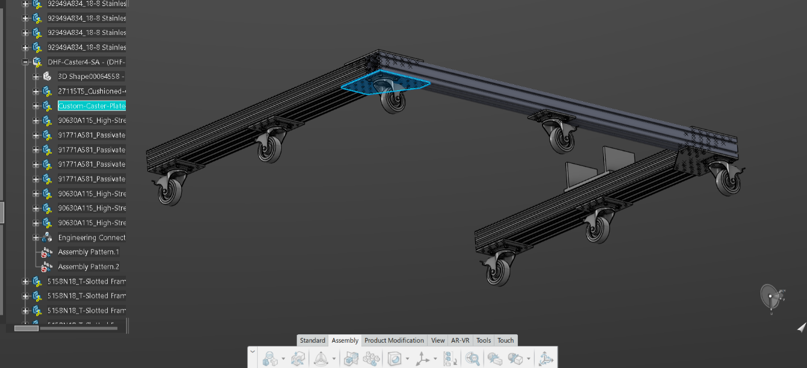
Custom Mounting Plates for Casters and Shaft Interfaces
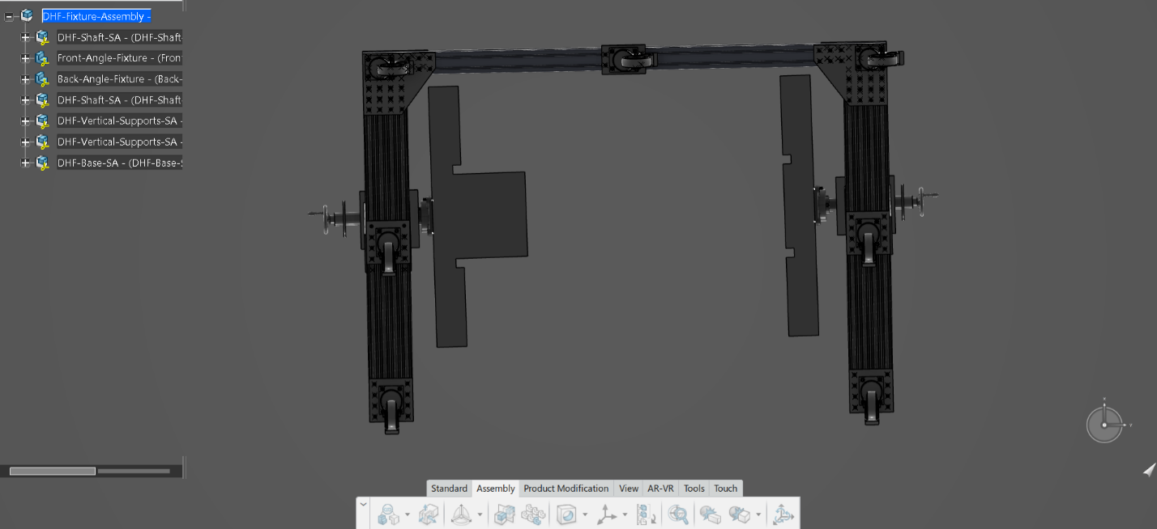
The first two images show the custom connection plates I designed — components that would be manufactured in-house to securely attach the casters to the T-slot frame and connect cylindrical shafts to rectangular lift columns. These plates were essential to transitioning between different geometries and ensuring proper load transfer. Designing these required precise dimensioning, tolerance consideration, and fastener selection to maintain rigidity while allowing modularity.

Shaft and Bearing Assembly
Below highlights the shaft and bearing system, a core part of the rotation mechanism. I engineered this assembly to support the full payload while enabling smooth rotation. A major challenge was preventing unwanted shaft motion and ensuring secure fastening within the lifting column. I solved this by integrating mechanical stops and carefully positioning bearings to distribute loads evenly and resist torsional forces.
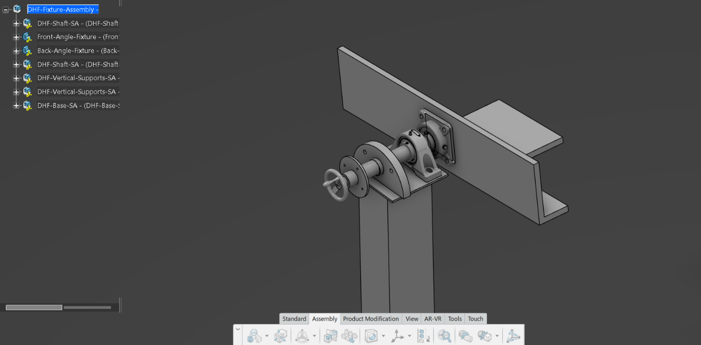
Lifting Column Selection and Integration
This next image illustrates the lifting column design and integration. Selecting the correct column involved extensive research and direct communication with manufacturers to evaluate load capacities, extension ranges, and mounting interfaces. This process taught me how to interpret technical datasheets, communicate design requirements to suppliers, and incorporate real-world constraints into the CAD model.

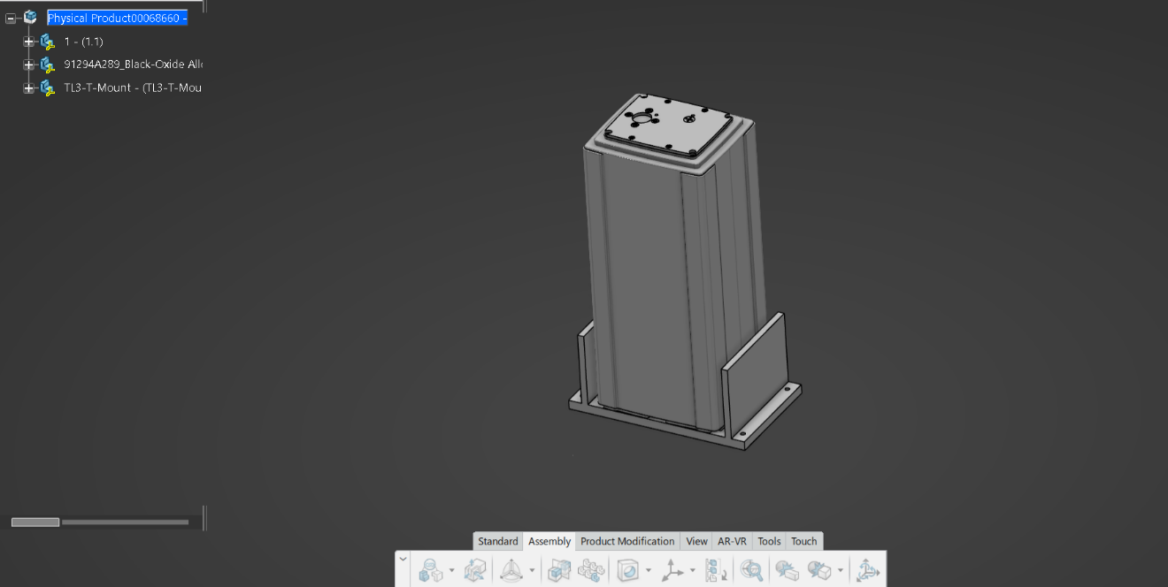
Key Challenges & Solutions
Throughout the project, I encountered several engineering challenges:
- Geometric compatibility: Designing interfaces between cylindrical shafts and rectangular columns required innovative bolting and plate designs.
- Structural balance: Ensuring the fixture remained stable and did not tip under rotation demanded careful center-of-gravity and load-distribution analysis.
- Load capacity: All components were evaluated for stresses under 1000 lb loads to ensure a safety margin beyond the operational weight.
- Real-world constraints: Component availability, cost, and manufacturability guided key design decisions and material choices.

Outcome & Skills Gained
While the fixture was not built due to shifting project priorities, this was a solo project that significantly expanded my skills in:
- CAD design and complex assembly modeling in CATIA V6
- Structural analysis and mechanical design principles
- Problem-solving and independent research for real-world engineering challenges
- Cross-disciplinary collaboration with engineers and vendors
This project deepened my understanding of design-for-manufacture, strengthened my engineering intuition, and motivated me to pursue future independent design projects — including plans to build my own drone.

Internship Contributions Beyond This Project
In addition to this fixture design, I supported the manufacturing of drone charging stations, GPS modules, and wire harnesses, assisted with 3D-printed component assembly, and prepared Boston Dynamics robotic dogs for integration. These experiences gave me hands-on exposure to robotics hardware, mechanical systems, and production workflows in a fast-paced engineering environment.

